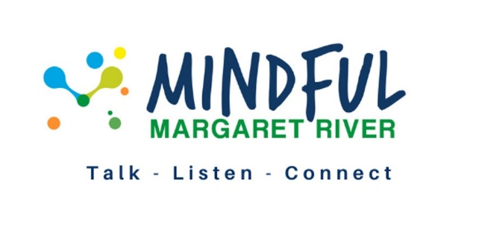

MINDFUL MARGARET RIVER
Committee nomination form

Members may nominate themselves for a role or nominate another member

Roles available are:

- Newsletter coordinator
- Membership coordinator
- Administration support
- Team representative – Sports
- Team representative – Youth
- Team representative – Men’s wellbeing
- Team representative – Women’s wellbeing
- Team representative – Family and Domestic Violence

Nominee……………………………………………………………………….

Nominated for (role)………………………………………………………….

Proposed by…………………………………………………………………..

Proponent signature…………………………………………………………

Date proposed………………………………………………………………..

The nominee must sign here to confirm acceptance of nomination

Nominee signature……………………………………………………………

For this nomination to be considered by the members, this form must be submitted by email to estatz@amrshire.wa.gov.au not later than 14 days before the Annual General Meeting.
Position descriptions
- Newsletter coordinator
Do you like fiddling with design programs or are a whiz at layouts and newsletters? Maybe you like to edit and have an eye for detail? Mindful Margaret River is looking for someone to put up their hand to help with either the layout, design or the editing of our biannual newsletter. We have access to Canva but are open to new ideas and suggestions.
- Membership liaison
The membership liaison role includes answering queries from potential members, providing information, devising regular communication activities and new member inductions. You will work closely with the Project Implementation Officer and/or Secretary.
- Administration support
Do you have experience in doing agendas and minutes? Do you have sound computer skills? Mindful Margaret River is looking for a volunteer to help with the agendas and minutes for our Board meetings. It is a way to get involved and lend your skills to Mindful Margaret River in a very practical way. Our meetings are held every 6 weeks and take about 1.5 hours on the day during school hours and of work between meetings.
Team representatives for:
- Sports,
- Youth,
- Men,
- Women and
- Family and Domestic Violence.
We are looking for volunteers that are happy to act in a leadership role for 12 months. The role would involve understanding the goals of your particular team, coordinating team meetings and liaising with the Project Implementation Officer to undertake local action and provide updates for the newsletter.

To find out more or to discuss the time involved, please call Erin on 0448 760 737 or email us at info@mindfulmargaretriver.org.au.

